Cloud Computing Overview (AWS CLI)

HOS06: Identity and Access Management (IAM) Part 2

Developed by Marvin Gold 12/20/2020

School of Technology and Computing



**Learning Outcomes**

* Setting passwords for IAM users
* Updating passwords for IAM users
* Setting Access keys for IAM users
* Deleting Access keys for IAM users

**Background**

Now that we have users created, we want to set initial passwords for the users and set up our login profiles for each user. After that we want to generate access keys for the developers. Access keys allow programmatic access to AWS resources, we had to use an access key to set up the AWS cli

**References**

*Using AWS Identity and Access Management from the AWS CLI - AWS Command Line Interface*. (n.d.). Retrieved December 19, 2020, from <https://docs.aws.amazon.com/cli/latest/userguide/cli-services-iam.html>

**Step 1: Log onto your Amazon EC2 Instance**

Log onto your Amazon EC2 instance using either OpenSSH, Putty, or from the AWS Management Console using ‘EC2 Instance Connect’ (shown below). Note all IP addresses used in this series of Hands on Skills will be released by the time we start class.

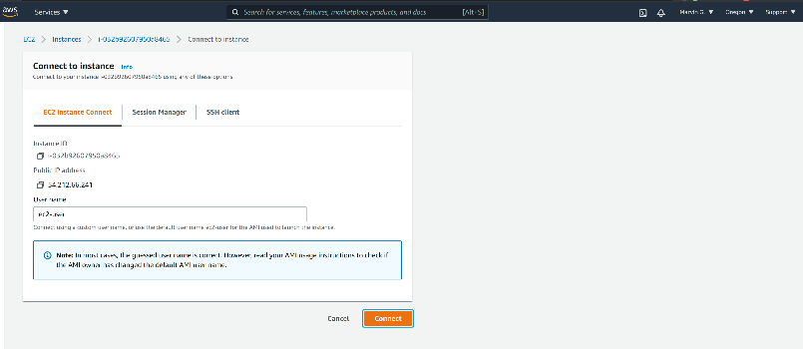

If you receive an error that you must first set your AWS Region and you must configure your AWS CLI, please follow these instructions.

<https://docs.aws.amazon.com/cli/latest/userguide/cli-configure-quickstart.html>  
  
Remember, do not use your root *account* for these operations. You should be using another IAM user. You should not have access keys to your root account.

**Step 2: Create a login profile**

From our last HOS, we should have 4 users   
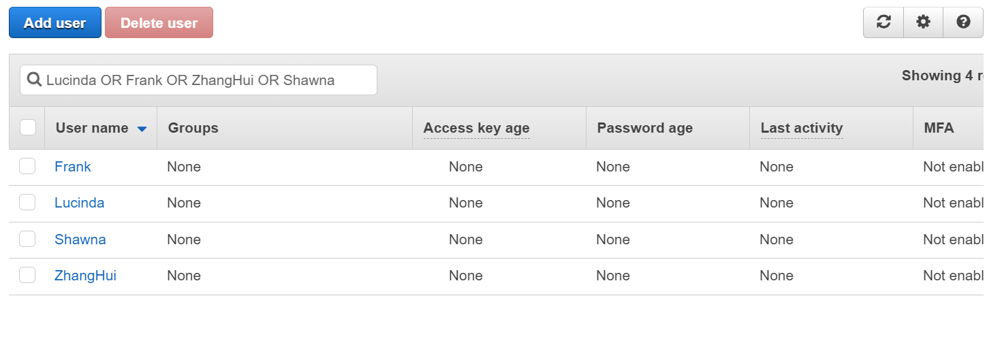

These users currently do not have passwords. We are going to use the create-login-profile command to generate some passwords for them.

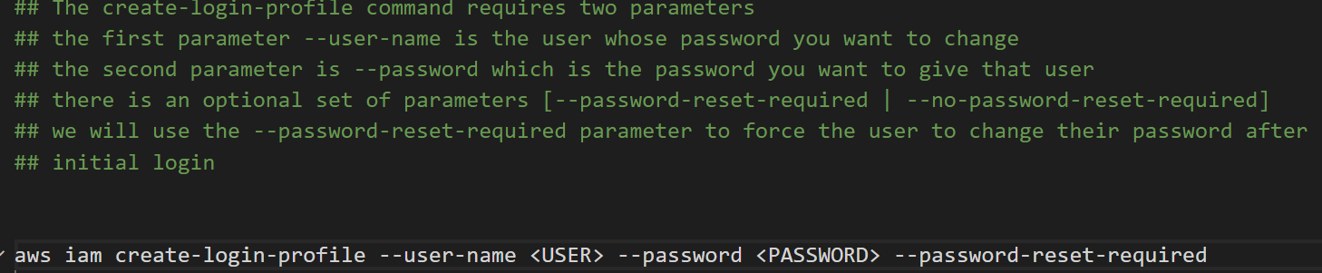

Here is an example of setting Shawna’s password to P@22WORd  
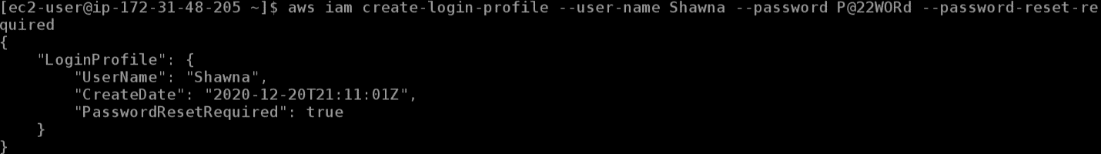

Set ZhangHui, Frank, and Lucinda’s passwords take **SCREENSHOTS of the OUTPUT**

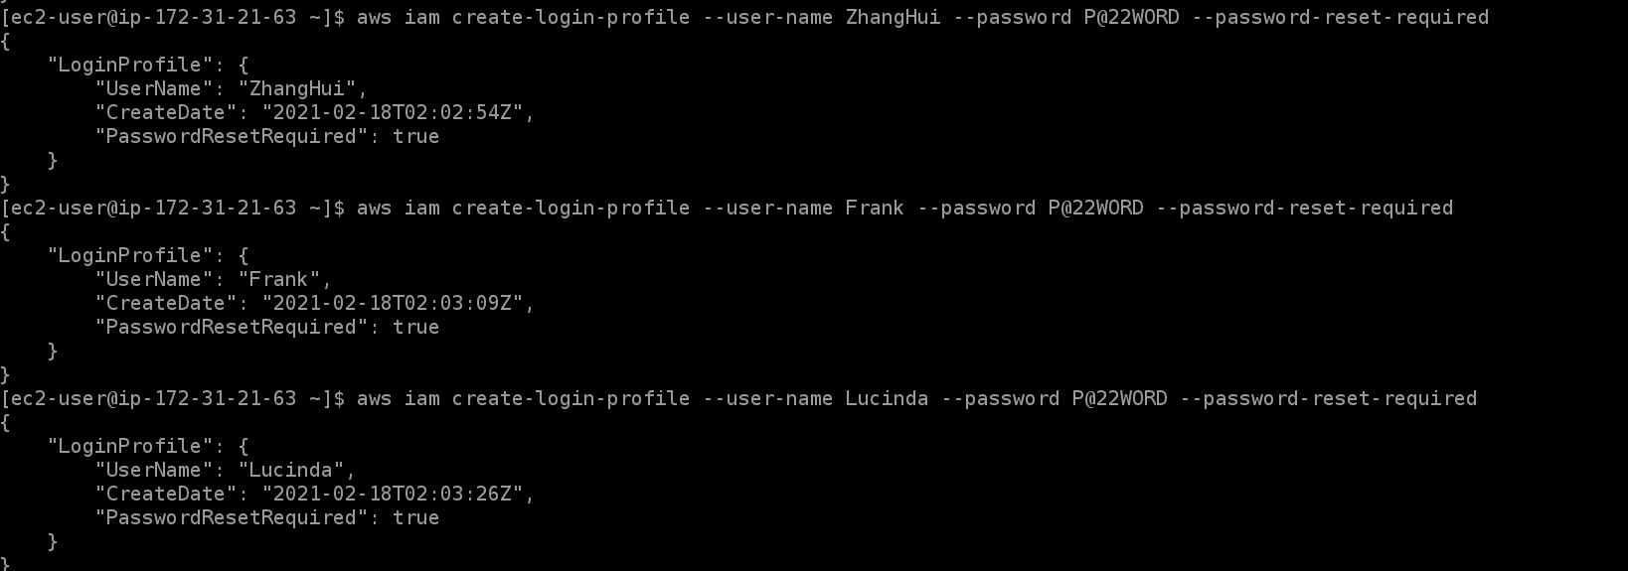

Looks like we received an email from Frank



Look around through the AWS documentation and describe how you would *update* Frank’s password. What command would you use?   
**Command:** aws iam update-login-profile --user-name Frank --password P@ssWORD

**Now, UPDATE franks password and take a SCREENSHOT**

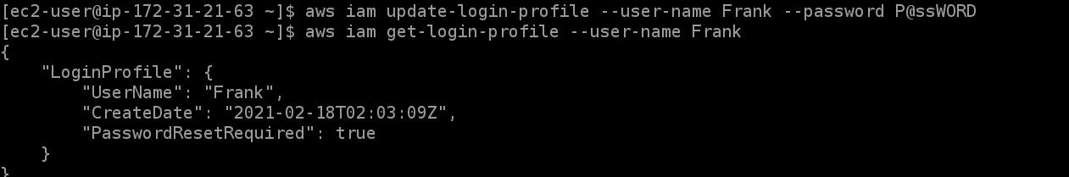

**Step 3: Generate Access Keys**

Access keys are how we programmatically access AWS resources through either the CLI or an IDE.

Our developers need Access keys to work on their upcoming project. But before we generate that answer this question.

T

Question: Should all developers share a set of access keys? Why or Why not?

Answer:

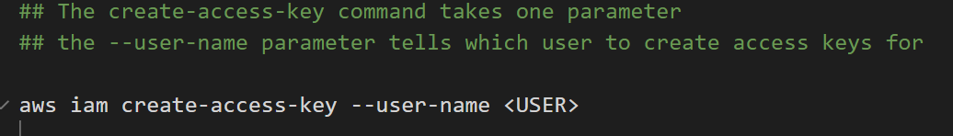

Create access keys for

ZhangHui, Frank, Lucinda, and Shawna

After you create the access keys, go to the IAM Console. <https://console.aws.amazon.com/iam>

Navigate to users and take a SCREENSHOT of the Access Key Age column. Do not take a screenshot of the CLI output because anyone with access to the Access Key and secret key has access to your AWS account. For security reasons we are going to delete these extra keys immediately.

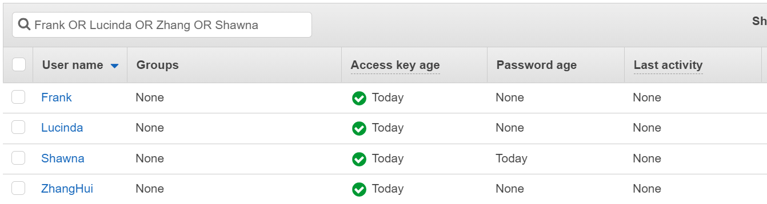

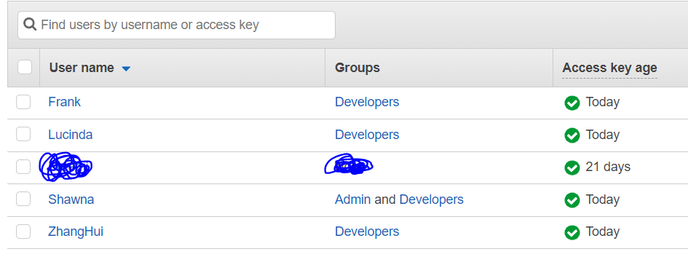

**Step 4: Delete Access Keys**

This project at the company has been completed, so we should remove programmatic access from our developers because they no longer need the access to the resources, we granted them. We will use the “delete-access-key” command to get rid of them.

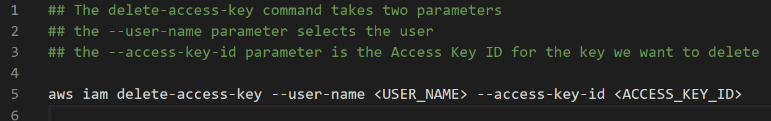

Use the delete-access-key command to delete, ZhangHui, Frank, Lucinda and Shawna’s access keys. Then take a **SCREENSHOT of the IAM Console showing NONE in the “Access Key Age” column.**

